- day-of-the-yea:
#code:
import java.time.LocalDate;

class Solution {
public int dayOfYear(String date) {
// Parse the YYYY-MM-DD string into a LocalDate object
LocalDate localDate = LocalDate.parse(date);

// Extract and return the day of the year (1 - 366)
return localDate.getDayOfYear();
}
}
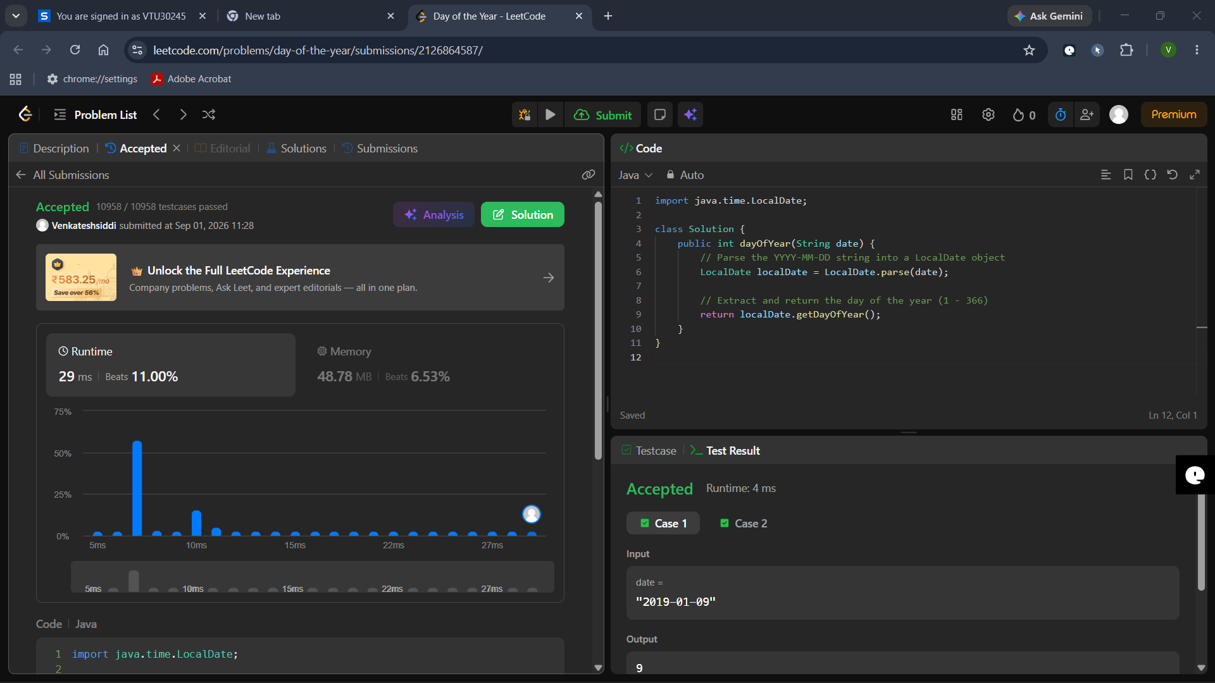

- Day of the Week:
#code:
import java.time.LocalDate;
class Solution {
public String dayOfTheWeek(int day, int month, int year) {
// Create a LocalDate object (expects year, month, day)
LocalDate date = LocalDate.of(year, month, day);
// Get the day of the week in uppercase (e.g., "SATURDAY")
String upperCaseDay = date.getDayOfWeek().toString();
// Convert to Title Case (e.g., "Saturday")
return upperCaseDay.charAt(0) + upperCaseDay.substring(1).toLowerCase();
}
}
